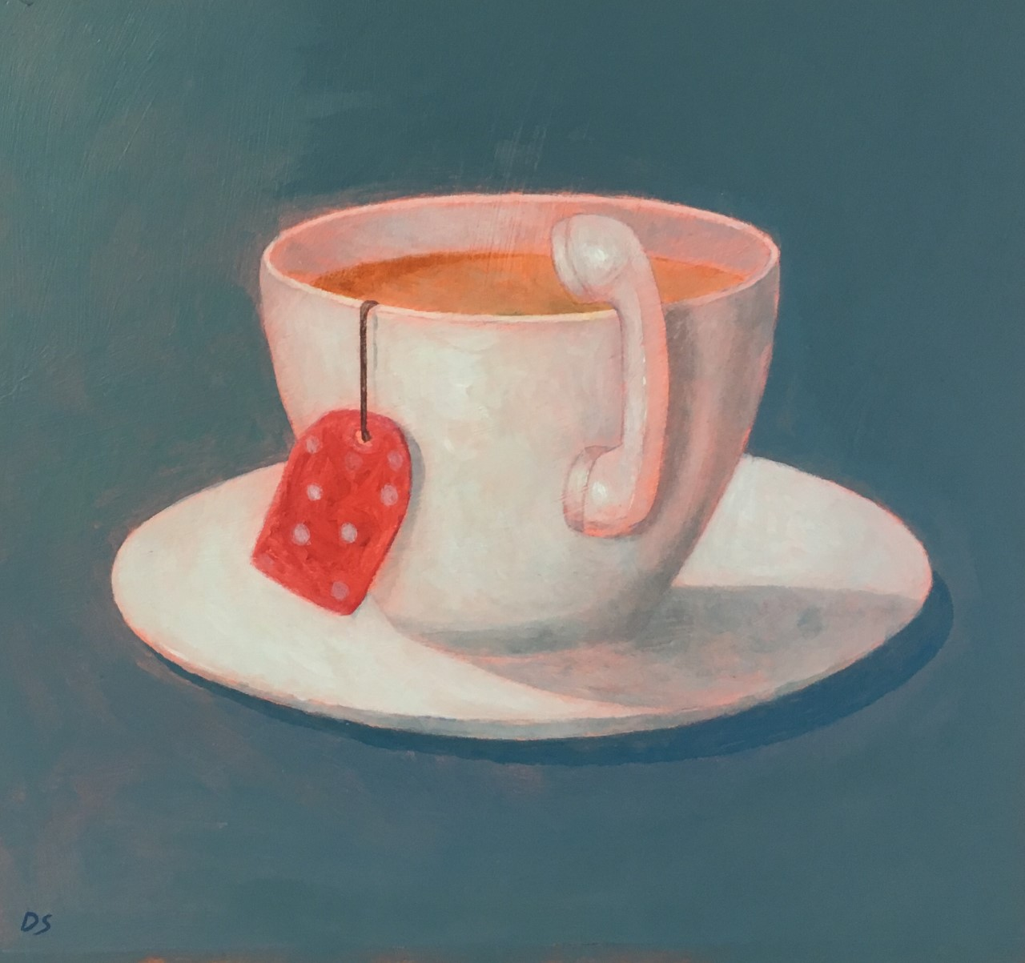

A Nice Cup of Tea

There's enough mystery
In a cup of tea
You and me drinking tea
Share the mystery
In our hands
Swirling round, round, round
Lift it up
Drink it down, down, down
Twinkle twinkle silver spoon
Full of wonder as the moon
A nice cup of tea has enough mystery for me

